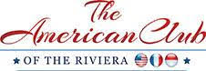

AMERICAN CLUB OF THE RIVIERA
CANNES FILM FESTIVAL LUNCHEON

IN MEMORY OF PRESIDENT EMERITUS BURTON GINTELL

FRIDAY 16th MAY 2025

CANNES YACHT CLUB

CANNES

BRONZE SPONSOR

Special thanks including Logo in the American Club of the Riviera Film Festival Luncheon Program

Mention on the American Club of the Riviera Website and Facebook Page as well as in the monthly Newsletter

1 complimentary place offered

Euro 1,000

