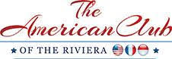

AMERICAN CLUB OF THE RIVIERA
CANNES FILM FESTIVAL LUNCHEON

IN MEMORY OF PRESIDENT EMERITUS BURTON GINTELL

FRIDAY MAY 16th 2025

CANNES YACHT CLUB

CANNES

GOLD SPONSOR

Full page advertising in the American Club of the Riviera Film Festival Program if requested

Special thanks in Program

Mention on the American Club of the Riviera Website and Facebook Page as well as in the Monthly Newsletter

6 complimentary places offered

Euro 6,000

